

|  |  |
| --- | --- |
|  |  |
| **THAMES** | **CBD REVITALISATION PROJECT** |
| **Problem statem** | **ent: How might the Thames CBD be** |
| **reimagined int** | **o a safe, inviting and thriving area?** |

**Table of Contents**

1. Main Participants 2

1.1 Thames Crew 2

1.2 Design Factory New Zealand 3

1.3 Thames Coromandel District Council 4

2. The Design Thinking Process 5

3. Secondary Research 7

4. Primary Research 9

5. Affinity Map 11

6. Redefinition 14

7. Timeline 20

8. References 22

9. APPENDICES 24

# 1. Main Participants

## 1.1 Thames Crew

**Thames Crew** consists of six students studying different disciplines at Waikato Institute of Technology, Hamilton.

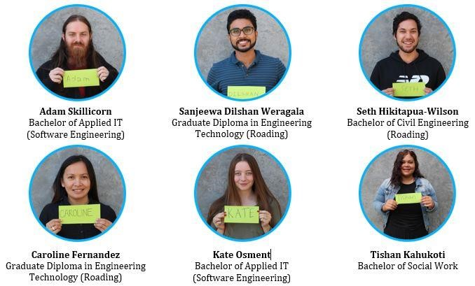

## 1.2 Design Factory New Zealand

“Design factory New Zealand (DFNZ) is a passion-fuelled, design-driven, cocreation space, where students work alongside the industry partners to solve complex problems. Design Factory brings together students, teachers, industry and community leaders from diverse backgrounds to help co-create the future.” DFNZ coaches the students and industry partners through human-centred design journeys, providing learning experiences that cultivate their skills as problem-solvers and solution-designers” (Waikato Institute of Technology, n.d., para. 1 and 2).

Design Factory NZ uses the design thinking process as a method for

creative problem solving to build up ideas and focus on solutions. Interaction Design Foundation (n.d.) states that “Design Thinking Process revolves around a deep interest in developing an understanding of the people for whom they are designing, by re-framing the problem in human-centric ways, by creating many ideas in brainstorming sessions, and by adopting a hands-on approach in prototyping and testing” (para. 1). While using this process, several tools are used to help the students focus on key elements of the problem such as clustering and affinity mapping which was further developed into themes and ‘How might we’ questions.

Moreover, DFNZ offers a wide range of learning experiences such as emotional intelligence workshops, reflections and collaboration with industries to help students develop their goals as well as further enhance their personal growth and development.

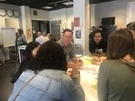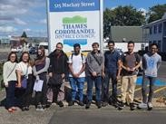

*https://www.facebook.com/DesignFactoryNZ/photos/pcb.764381190720518/764379217387382/?type=3&theater*

Figure 1a (Left) - Meet with the Industry Partner and discussion about Creativity Brief at DFNZ, Wintec, Hamilton February 25, 2020

Figure 1b (Middle) - Site visit and interview at Thames March 10, 2020

Figure 1c (Right) - The Thames Crew group pictorial in front of DFNZ, Wintec, Hamilton

## 1.3 Thames Coromandel District Council

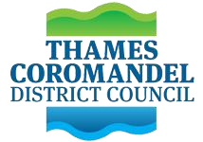The Thames Coromandel District Council (TCDC) was created from the amalgamation of the Thames County, Thames Borough and Coromandel County councils in 1975, and is led by the Mayor of Thames-Coromandel. TCDC is one of the biggest employers on the Coromandel. They oversee the Coromandel Peninsula and deal with the challenges and opportunities within the District. According to the Thames Coromandel District Council page, they “Provide a wide range of essential services for residents and visitors, ranging from libraries to dog control to water

services”. They play a vital part in addressing coastal erosion and managing the effects of climate change in their area, especially for their 400km of coastline - to ensure future generations can enjoy this great asset. (Thames Coromandel District Council, 2020).

The Council exists to ensure the communities have a good quality of life - both now and in the future. That means that, as a local authority, they not only need to identify what the communities need but also to have a demonstration on how to fulfil those needs.

The Thames Coromandel District Council has put forth a project which is to “Reimagine Thames CBD in a safe, thriving and inviting way”. Mayor Sandra Goudie spoke more about this in an article saying, "Whangamatā lead the way, it's been followed by Whitianga with its amazing spaces, and Coromandel Town is an absolute delight the way it is, now it's Thames' turn." (Tantau, 2020). According to TCDC, Thames CBD is lacking engagement, connection and vibrancy. It has been described as being uninviting, at times unsafe and is not thriving, which contributes to this ideology of Thames being ‘just’ a ‘pass through town’. Mayor Sandra Goudie expressed her vision of CBD and said: “We want spaces that are pedestrian-friendly, community-friendly, and give the ambience of being in the living room, we want to create a good vibe in Thames, and I think now is the time we need to have those discussions." (Tantau, 2020).

# 2. The Design Thinking Process

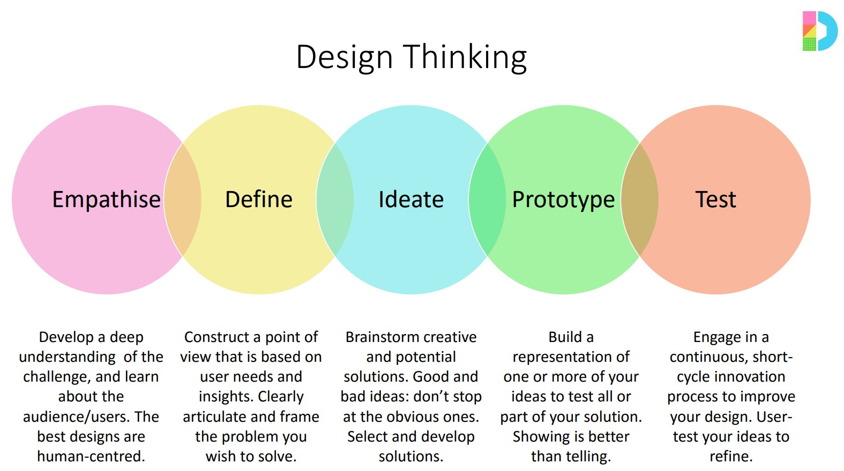

*Figure 1 Design thinking process https://learning.wintec.ac.nz/pluginfile.php/1882098/mod_resource/content/1/Design%20Thinking%20poster_handout.pdf*

Design Thinking is a design methodology that provides a solution-based approach to solving problems. It is extremely useful in tackling wicked problems. Australian Public Service Commission (2018) defines that “Wicked problems are problems that are difficult to clearly define, have many interdependencies and are often multi-casual, proposed measures have unforeseen consequences, often not stable and there are no clear solutions” (para. 13-17). Design Thinking includes five stages namely; empathise with the users, define users’ needs, problems and insights, ideate by creating ideas for potential solutions, prototype and test solutions. In this report, only the first two stages which were used in DFNZ to date are discussed in detail.

The first stage of the Design Thinking process is Empathy. Interaction Design Foundation (n.d.) states that “Empathy is an important element in Design Thinking and Human-Centred Design wherein empathy is the ability to see the world through other people's eyes, to see what they see, feel what they feel, and experience things as they do. That is, attempting to get as close as possible, putting aside their own preconceived ideas and choosing to understand the ideas, thoughts, and needs of others instead. Empathy helps them gain a deeper appreciation and understanding of people's emotional and physical needs, and the way they see, understand and interact with the world around them. It will also help them to understand how all of this has an impact on their lives generally, specifically within the contexts being investigated” (para. 1-3).

During this phase, the students had the chance to meet, observe and engage with their industry partner, Thames Coromandel District Council. TCDC gave them a background of the problem statement and answered the questions in the Creativity Brief. After the discussion, the students were then ready to gather information about their target user and one way to build this stage was by conducting empathy interviews. The Design Gym (2020) defines that “Empathy interviews are conversations with the people who are impacted by what they are designing - the end-users, the surrounding stakeholders who will help them produce the outcome” (para. 7).

Thames Crew created interview questions for the key stakeholders and developed interview techniques including questioning and active listening. Apart from the questions, the students also had identified ethical issues in conducting interviews to deeply understand the context of it. These interviews were conducted on three separate days allowing the team to simply observe, deeply listen and actively capture important and interesting insights from the stakeholders.

The next stage of the Design Thinking Process is dedicated to defining the problem. This stage involves putting together all the information created and gathered during the Empathise stage. During this phase, the students analyse and synthesise the empathy findings into compelling needs and insights and scope a specific challenge. Interaction Design Foundation (n.d.) defines that “Analysis is about breaking down complex concepts and problems into smaller, easier-to-understand constituents, on the other hand, synthesis involves creatively piecing the puzzle together to form whole ideas” (para. 5).

After digitizing data from the interviews, affinity mapping was introduced. “Affinity map is a method which helps to gather large amounts of data and organize them into groups or themes based on their relationships” (Interaction Design Foundation, n.d.). This process involves identifying all key information, grouping the key information into categories, clustering similar insights and giving a general heading and lastly, re-clustering similar key insights into key themes. These themes made an actionable statement and provided the group with the ability to collectively develop the “How Might We” questions.

# 3. Secondary Research

With the problem statement, “How might the Thames CBD be reimagined into a safe, inviting and thriving area, TCDC also gave an outlined background information to the group and their desired outcomes as to achieve a prosperous, liveable, clean and green district. The outlined background information are as follows:

* Homelessness - car parks
* Drug-dealing and using – on streets/civic building toilets
* Graffiti on buildings
* Aggressive behaviour in streets and shops, loitering
* Feeling of unsafe area
* Methadone clinic
* Friendship house clientele and their dogs

Secondary research was performed in order to gain a broader and deeper understanding of the data collected from the primary research. This secondary research used existing data such as books, articles, journals, or the internet so as to validate and support the existing research.

Thames has a small and regional economy and it has faced issues due to the shifting of global markets and drifting skilled people to other urban regions. Revitalising its existing resources and unique characteristics can considerably improve the standard of living and boost its economy.

Thames is a special and unique place as it represents New Zealand’s history; it can be still experienced by looking at the aesthetics of the town and culture. However, that era has passed while its uniqueness is far from the 21st century towns and therefore it has become a “pass through” place rather than a destination.

Thames is a town located at the southwestern end of the Coromandel Peninsula. The Coromandel Peninsula has a land area of about 230,000 hectares and has 400 kilometre of its coastline. Also, Hauraki Gulf Marine Park is also situated within the peninsula. There are many advantages due to its strategic location and its unique characteristics such as attracting people to visit and explore the peninsula, however, Thames, on the other hand, having a coastal environment and rugged terrain is subject to coastal erosion, rising sea-levels, flooding, storms and landslides. (Thames-Coromandel District Council Infrastructure Strategy, 2018)

Given the above problem statement, making a thriving city means accommodation for every demographic, low levels of crime, a clear sense of direction and widely shared visions with the community, have an inviting streetscapes, access to jobs and education, organized events for the community and entertainment for all ages like bowling, laser tag and arcade. Thus, for a city to thrive and remain productive, the place must continually adapt and evolve so that people will call the place ‘like home’. Also, there needs to be access in regards to housing and transportation, and availability for jobs and education. (Cortese, 2019, para. 2)

The demand for cities is changing, primarily focusing on ‘Talented people’. Cities need to attract people who will be willing to live and grow in their desired city. For example, if people like entrepreneurs were inspired to develop a company or brand, then this will increase the job opportunities and increase demand for more people to live there. Due to the rise of automation, labour is slowly decreasing resulting in a demand for more educated people.

(Versey, 2019)

In addition, “countries such as Australia, Brazil and Spain , their governments are partnering with technology firms to make cities “smarter” by retrofitting various city objects with properly designed technological features in order to make cities safer and potentially more userfriendly” (Technology is making cities ‘smart’, but it’s also costing the environment, n.d.). This emphasis on making cities more “smarter” will improve safety and security in the area as well as help the government plan and respond to unexpected events.

Thames needs to redevelop some of its areas not just to attract tourists or visitors, but rather to motivate entrepreneurs and businessmen to invest in the town as well. Since Thames is a gateway to the Coromandel Peninsula, there are opportunities to bring people in not just to pass by but to attract them to live there.

Thames has also experienced a feeling of unsafety and anti-social behaviours. In 2019 articles reported Thames had over 20 cars broken into and many youth and adolescents caught robbing houses (Stuff, 2019). A recent article reported two men in Thames who were in possession of five firearms as well as drugs (Stuff, 2020). It has been evident through secondary research that anti-social, delinquent and criminal activity is a problem in Thames and has affected the way in which locals engage in Thames, the CBD and as a community.

According to the Journal of Environmental Psychology, “Feelings of safety and security, civic participation, and improved wellbeing, have all been associated with a strong sense of community. Sense of community is often defined as a feeling that members matter to one another and to the group, and a shared faith that members’ needs to be met through their commitment to be together. Sense of community appears to be significantly associated with a public open space. The presence of public spaces in local neighbourhoods – irrespective of whether used frequently or not – may be important in enhancing a sense of community amongst residents. The benefits of a strong sense of community are numerous, and potentially include increased participation in community affairs and better physical and mental health” (Francis et al.,2012, p. 2).

The revitalisation plan of Hastings focuses too on public spaces that will reinforce the city as a key destination, recognise and celebrate its character, history and culture, create connectivity to the community, improve its accessibility as well as create vibrant and functional places that will further complement the businesses around it. (Hastings District Council, 2013, p. 4).

# 4. Primary Research

Primary research involves the gathering of information through interviews with the help of qualitative research and data collection methods.

**Qualitative Research Method**

A Qualitative Research method is described as,

*“A situated activity that locates the observer in the world. It consists of a set of interpretive, material practices that make the world visible. These practices transform the world. They turn the world into a series of representations, including field notes, interviews, conversations etc” (D’Cruz & Jones, 2013, p.68)*.

Qualitative research allows the researcher to gather data in terms of the meaning that individuals bring to occurrences and helps the researcher interpret or attempt to make sense of these meanings (D’Cruz & Jones, 2013, p.68). By using this research method, it produces data concerning quality and includes exploration of values, processes, experiences, language and meaning among other things. This allows for research that is transformative and emancipatory (Pihama, 2003).

**Data Collection**

The group engaged in ‘semi-structured interviews’. Semi-structured interviews are formal and guided one on one discussions, that is done face to face with the participants (May, 2010). This data collection method is beneficial to use, as it allows the participants to share information. They may have not been comfortable sharing within a group setting and having it structured means they will be able to draw on specific information that they feel will help in concluding this research.

To gather a diverse range of data for this Research Project, the group undertook qualitative interviews with 20 people. These include some members of the District Council, members from the Thames Business Association, Librarians, a Zeal representative (Youth Work Organisation), Accommodation Providers, Tourists, members of the general public, Restaurant Owner within Thames CBD, and Tourist Guide. The intention of having a wide range of respondents from locals, business owners to elected staff was to get a broader range of perspectives as possible and since they were significantly involved in the revitalisation plan of Thames CBD. The group used open-ended questions to help in gathering more specific data for their research.

The key interview questions are as follows:

* What does a thriving community look like to you? Why is that important to you?
* What does a safe community look like to you? Why is this important to you?
* What does an inviting community look like to you? Why is this important to you?
* What is your understanding of community engagement? What is community engagement like in Thames?
* Do you think there is a strong sense of community in Thames? What supports that and what are some of the barriers to that?

These were the five main questions as the team felt these questions would support in generating data specific to the problem statement. Importantly the team were able to successfully use them in all the diverse interviews.

Here are some of the key findings gathered from our data collection stage;

* Thames is considered only as a “pass-through” for visitors.
* Locals found it difficult to find affordable and suitable accommodation.
* Businesses within the CBD have a limited product range and quality.
* There are some businesses closing down.
* Drugs, intoxication, intimidating youth, break-ins in shops are some of the reasons for anti-social behaviours within the CBD.
* Some people in the community want open areas for community connection. ● There is a need for infrastructures to be improved.
* The main street, Pollen Street is ‘dying’ and lacks vibrancy.
* Thames has a lot of attractions however, there is a lack of advertisements of what is in town.
* Miscommunication between the Council, Business Association and the community needs to be resolved.
* Artworks and signages would improve the current appearance of the CBD.

**Method of Analysis**

The method used to analyse the data collected and key findings were Thematic Analysis which is a method for analysing data when doing qualitative research. This is an interpretative approach that is based on categorizing the collected data into particular themes to understand the complexity of meanings gathered from the study (Lehmann, Murakami & Klempe, 2019, p.4). The group did this through:

* Identifying key information
* Writing insights to post-it notes by colour coding into categories
* Clustering insights
* Clustering insights into Themes
* Themes into How Might We Questions

This will be further discussed in the Affinity Map on page 9.

# 5. Affinity Map

After completing the interviews, observations and engagement with users, the group began Thematically Analysing the data. Because the group had ethically recorded the interviews, it was easy for them to digitize it. Firstly, they took out key points and quotes that stood out then transferred that information to post-it notes into Miro. Miro is a cloud-based collaboration tool that is used for research and ideation and allows the group to collaboratively work on the project without being present as a group. The group colour coded this information and placed it into categories of the people/types of people interviewed e.g. Zeal, Council staff, Librarian etc.

After the key information was placed into these categories, the clustering stage began. Clustering refers to the process of organising objects into groups whose members are similar with respect to a similarity or distance criterion (Foley, 2018). Then, clustering the information into themes such as Crime, Infrastructure, Council etc. The team had created a lot of large clusters, so they began to re-cluster the insights created and divided them into sub-clusters.

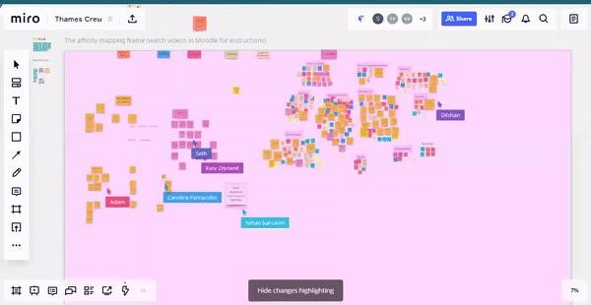

After completing this task, they collaboratively read through the sub-clusters and summarised the insights onto large post-it notes placed next to the clusters. An insight is when serious and consistent analysis has taken place to intentionally translate large amounts of data into compelling and concise findings. It is a skill that requires deep thinking, creativity and persistence and is important in terms of inspiring and creating new ideas for service and product development (Dalton, 2016). This allowed the group to form a hierarchy of major and minor insights. Later, they collectively took the key insights and redefined them. This provided them the ability to collectively construct the How Might We (HMW) Questions.

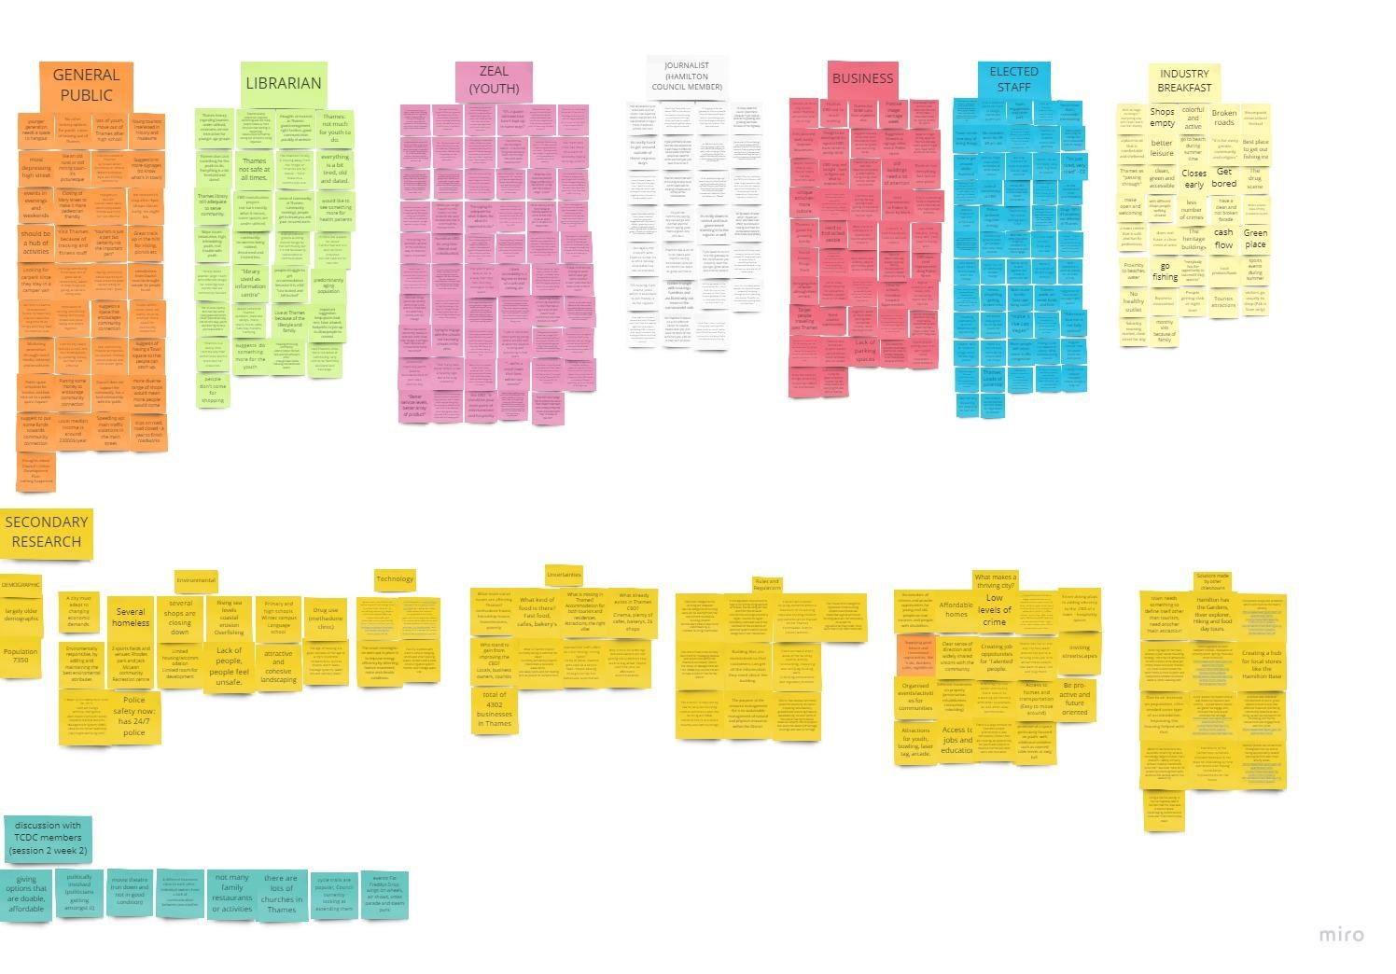

*Figure 2 Clustering Frame*

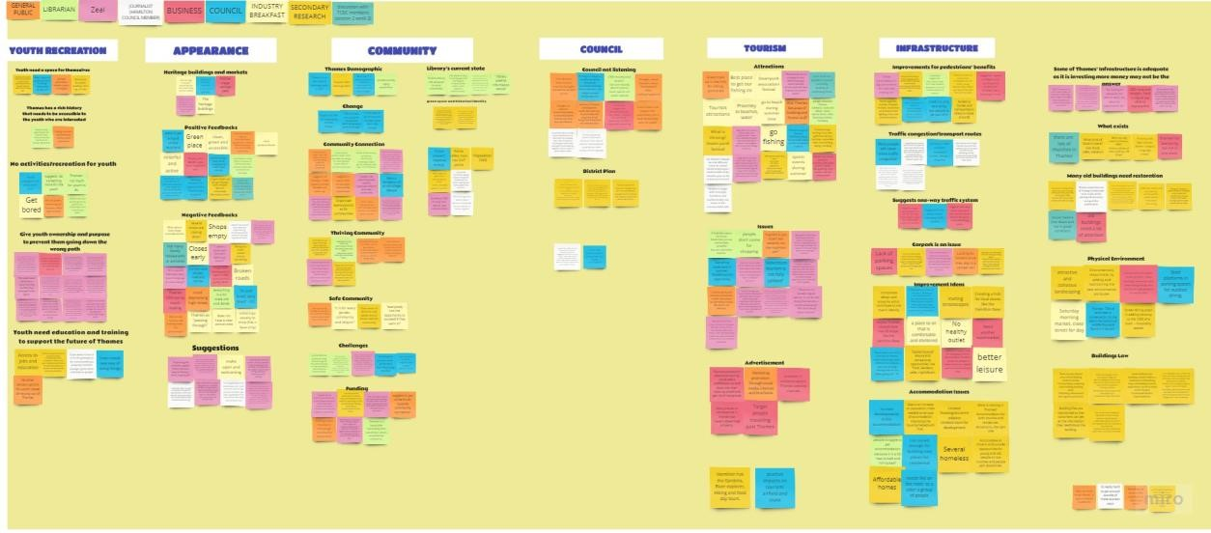

*Figure 3 Affinity Map Frame 1: left*

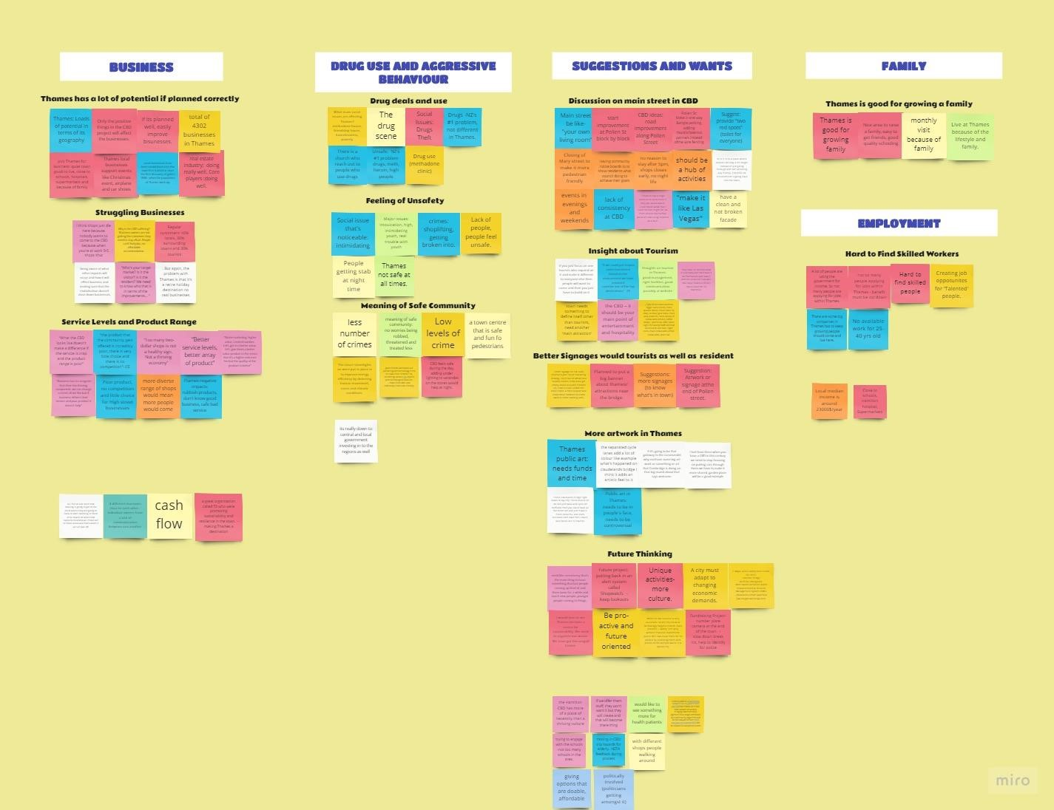

*Figure 4 Affinity Map Frame 2: Right*

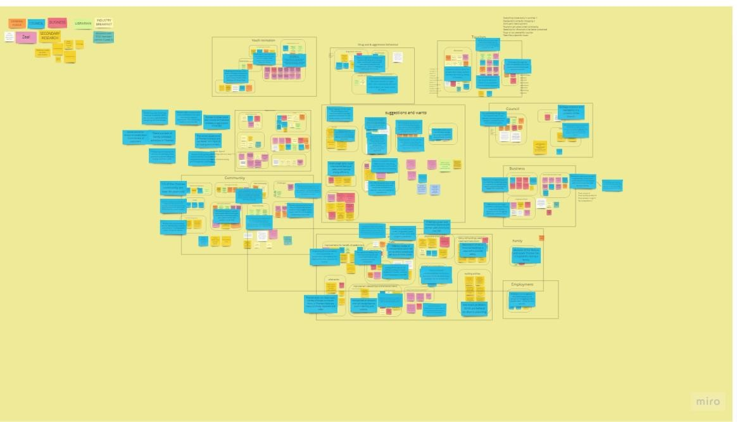

*Figure 5 Insights Frame*

# 6. Redefinition

The process of Redefinition is described as the process or act of causing people to consider ‘things’ in a new way, we have used redefinition as a method to re-evaluate the problem statement by looking through the lens of ‘How might we’ questions.

**What are How Might We questions?**

How Might We (HMW) questions are the best way to broaden Brainstorming and other Ideation sessions. By framing your challenge as a How Might We question, you’ll prepare yourself for an innovative solution in the third Design Thinking phase, the Ideation phase. The How Might We method is built in a way that creates opportunities for new ideas, acknowledges that we do not currently know the answer, and encourages a collaborative approach to solving it (Dam & Teo, 2017).

The main insights clustered under the How Might We (HMW) questions are as follows:

**1. *How Might We* make Thames CBD more attractive and welcoming?**

***Insights:***

* Thames has a lot of heritage buildings around the CBD. If the area was improved, then everything would look sharper.
* Thames is a green place with colonial architecture which could be an attractive feature for visitors and Thames residents,
* Interviewees found that the town centre is easy to get around,
* Some interviewees felt that visitors of Thames bypass the main street and there is no inviting entranceway to the CBD.
* The current appearance of Thames is 'empty' and 'outdated' and isn't much of an inviting environment.
* Thames is a gateway to Coromandel but tourists or any potential visitor pass through for a quick stop.

These statements identify people's view of Thames in terms of how attractive it is. Locals generally have some positive feedback on how they feel about the town. Some of the feedback was, “There is a sense of community”, “Walking distance to supermarkets are short”, “Great place to raise a family”. On the other hand, other people have different views. Some stated that “It does not have a clear central area”, “Thames CBD is not that inviting”, “Main street and stores are empty”, “It is tired, just tired”. This creates a problem of, how can we improve the CBD?

“Thames is the gateway to the Coromandel.” This was commonly used from the Thames community. If we found a way to attract the people passing through Thames, the CBD will look a lot more active.

Some interviewees commented that Thames already have some great assets within the CBD. The Heritage buildings were frequently mentioned, they help with providing a background of Thames history such as gold mining, kauri timber milling and heavy manufacturing. These buildings still stand to remind them how prosperous an area Thames was.

From the insights, it is clear that improvements within the CBD are needed to make it more attractive and welcoming.

**2. *How Might We* create public spaces that encourage community connection?**

***Insights:***

* Thames has an interesting historic identity that could be utilised when creating public areas and green spaces.
* Thames communities feel that they are financially limited however they suggest some funds towards encouraging community connection.
* The community wants a public space/square which encourages community connection and it’s a place where events and activities can be held.
* Thames community groups find it challenging to communicate and work together. ● Events are organised but some groups feel that the event is not targeted to them.

This question identifies that the locals have a need and a want for their own public space to encourage community connection. Many of the interviewees talked about wanting a green space or a public square that they can utilise. They suggested using Thames historic identity when creating these public areas. Interviewees also said this place should be a place where events and activities can be held. A space where everyone can meet would encourage communication and connection.

From the insights, community groups find it hard to communicate and work together. A public space could give community groups a mutual ground to work with, this could be less intimidating for people. A public space is usually suited for a large variety of people, is usually something everyone in the town knows about and knows where it is, somewhere in or around the CBD would be ideal, this is because it is a central place. “Arrange public meetings and invite the Council staff to address people's problems.” Meetings like this could be held in that public square or space. It will be a place where everyone would know about and it would not seem as intimidating to people.

The space should identify with Thames identity, as discovered in the insights, using Thames historic identity would be a great way to do this. Making the space have an identity that the community to be proud of will help keep it cleaner, safer and more inviting because the public will care about this area. Businesses could run events at the square or space, this would create community connections and possibly help gain the businesses new customers. Another idea is having groups using this space. For example, one interviewee from Thames said: “we are in discussion about setting up a writers group”. Organising this group to meet in a public space is a good idea, because it is a mutual space and because the group would get more attention from people passing through curious as to what they are doing.

Overall, a public square or space would help the CBD thrive, more people would be out and about, and a public space can encourage the public or businesses to hold more events and activities leading to a deeper community connection.

**3. *How Might We* support businesses in the CBD so they can thrive?**

***Insights:***

* Business is an important part of any town or city, so when planning it is important to consider them and their potential, to help support the community.
* Businesses with limited product range/quality and service level will struggle to thrive.
* If businesses are lacking in competition, then there is a limited incentive to innovate and therefore they may stagnate.
* Stores are either empty or closing from the lack of customers.
* Low customer numbers, incorrect target customers, and shops closing early mean Thames businesses are struggling with their customer base.

This question is important to look at because these improvements would serve to make the CBD thriving and possibly more inviting for both residents and tourists or visitors as they all impact a person’s opinion of the CBD. “The potential for Thames is right up there, if we could activate Thames.”

Business is the lifeblood of any city or town, if it was just residential people would have to commute large distances for work or recreation or shopping which would encourage people to move if the proper infrastructure isn’t there to support them. However, having poor quality business may have a negative impact on the image of CBD. “Too many two-dollar shops is not a healthy sign. Not a sign of a thriving economy”.

The TCDC needs to look to the businesses at least in part for the thriving aspect that they’re asking for but for that to happen businesses must be stable – they need to thrive not just survive. A good product range, quality of service or product and stable customer base are good indicators for a healthy business. Having competition can force a business to up their game and further improve the service or product they offer. “…If thriving is an economic issue, then the appearance of the street may contribute to that in the sense it might draw some business in.”

The CBD’s existence is predicated upon business – it is the “central *business* district” – therefore having healthy businesses are important because the CBD feeds the economy of a town or city and that economy is what supports community which encourages growth. If there is no growth a town would either stagnate or diminish and die. “It’s about getting communities to understand if they don’t invest in themselves, they will die.”

**4. *How Might We* revitalise the Thames CBD by improving infrastructure and accessibility to accommodate future demand?**

***Insights:***

* There is a lack of free spaces for vehicle parking which is a major problem in the Thames CBD.
* Improving the accessibility and connection of pedestrians throughout the CBD will further enhance its vitality.
* Different modes of transportation within the Thames will be able to access and get around the places.
* Thames is a small town so traffic congestion could become a major issue with a higher population.

It is felt that the focus of the CBD needs to be around creating a shared environment, the focus on putting cars through them needs to shift to re-creating areas that are only for walkers and cyclists.

This question is important to address as infrastructure and accessibility are vital elements for economic growth and convenience of the people. Most of the people from interviews raised the idea of improving infrastructure and accessibility in the CBD; as they felt the current situation or plan is way behind when compared to other vibrant cities around the country. Also, people in the CBD faced major problems in vehicle parking and eventually that led to traffic congestion due to people searching for parking places.

Some interviewees said that creating a one-way traffic system down the main street could be a solution to current demand by reallocating road space within the CBD to parking and pedestrians and some of the spaces could be converted as green areas or art exhibit areas either end of the street. Also, some people from the business association said that the CBD needs to be revitalised to make it comfortable enough for people to want to stay and walk around.

The expansion or improvement in infrastructure facilities such as buildings, roads and transport will help to grow existing industries and promote other industries to come and invest. Eventually, this will help to overcome other issues such as unemployment. A better public transport system is also an important thing to address future demand.

Therefore, it is clear that improvement of the infrastructure and accessibility by addressing the future demand is a necessity to make the Thames into a safe and inviting city.

**5. *How Might We* provide more accommodation to tourists and locals for them to choose Thames as a destination?**

***Insights:***

* Thames is geographically situated within three rivers, ranges and firth.
* Thames is a great place for people who enjoy outdoor activities like fishing, hiking or beaches.
* Thames was not zoned enough to build new homes.
* There are several cases of homeless people.
* Thames is a gateway to Coromandel but tourists or any potential visitor pass through for a quick stop.
* Promotion through the internet such as websites and social media and brochures may increase tourism.
* Thames does not cater for tourists because there is no available infrastructure at hand. People just pass through as there are not many accommodation facilities.
* The main barrier to choosing Thames as a place of residence is the lack of property and houses and lack of rentals.

This question addresses the need to construct more residential and commercial buildings to accommodate a wider range of population as well as tourists. One of the respondents said, “One of the main problems with Thames is they are 30 to 50 years behind on the district planning. They have very poor districts when it comes to housing. They have not zoned enough places to build new homes''. This clearly signifies the issue of homelessness that has been a concern due to the shortage of housing facilities.

Also, a significant number of people from the interviews mentioned that the main barrier of one coming into Thames whether it is intended for a visit or a stay is the lack of property and rentals and limited choice for accommodation which mostly do not have building improvement like a form of heating. One of them said, “People struggle to get accommodation in Thames because it is a bit “sea-locked and hill-locked”. They also emphasised that although Thames has a lot of potential in terms of its geography, people just pass-through for a quick stop. Some interviewees also believed that there were no advertisements presented either in brochures or through the internet.

From the insights, it suggests that Thames needs to have adequate accommodation to invite more people to explore Thames without just passing it. Addressing the issue of housing will also help to address homelessness and will further create a more safe and secure community.

**6. *How Might We* create a new way of engaging youth within the community?**

***Insights:***

* Youth want to be part of the future of Thames and they want to be supported in education and training to help create new ways of doing things.
* Youth want a space that they can hang out in and activities they can engage in.
* Thames locals expressed concerns about the minimal and negative engagement youth currently have within Thames and feel there is a need for new ways of attracting youth into education, community and social activities.

This is an important question to address because it is evident through the gathered data that youth engagement in Thames and within the CBD is minimal, uninviting and makes other community members feel unsafe. One interviewee noted that “Youth would hang out at the park and intimidate older people, they would ask them for money, ride around on their bikes doing wheelies and swearing which was quite disturbing”. A common theme from the gathered data was around youth being ‘bored’ and there being ‘nothing for youth’ within Thames and the Thames CBD. From secondary research, boredom was identified as being a catalyst for anti-social behaviors, youth criminality and other issues such as drug use, truancy and suicide (Newton, 2001, p.i), all of which are detrimental to youth development and contribute to an unsafe and uninviting CBD and environment. This emphasized the need for generating better engagement, spaces and activities for youth that works towards giving them a purpose and a sense of connection and belonging.

We have found a Report from the Thames-Coromandel District Council, called the ThamesCoromandel District Youth Strategy 2013. This report highlighted the fact that there is a perception that young people are not a priority to the council and within the township, and there is not a single organisation that delivers a holistic service that meets all the needs of young people as they grow and develop (Thames Coromandel District Council, 2013, p.3). The report discusses how youth are less likely to offend if they:

* Are actively engaged in education, training or employment
* Have a sense of self-worth
* Have recognition and praise for positive behaviour
* Have positive and pro-social friends
* Have strong connections to the local community (e.g. sport/cultural activities)
* Teachers and the community
* Have positive role models

(Thames Coromandel District Council, 2013, p.16-18).

It also highlights the need for a youth hangout space and creating a vibrant range of social and leisure options. Including this report in this explanation is important as it supports why the group have chosen to address this ‘How Might We’ question, as well as addressing that the group have acknowledged the previous discussion around the inclusion and positive enhancement of youth within Thames and the need for it.

Youth are always referred to as the leaders of tomorrow, so it is important for the existence of Thames, that the council and community focus on youth and support them in positive community engagement and personal development. An interviewee said, “Many young people are told what to often do when they have issues of authority, especially in Thames, I can understand extreme reactions against that, so I think kind of showing them we don't have any agenda or expectations we just want to get to know them, want to hang out and do what they are interested in.” On interviewing staff members from Zeal (youth work organisation), they emphasised the fact that “Youth have this independence and this pioneering mentality” and said, “I think it's important to give it to young people and ask them ‘What do they want?’ and that helps them give them that ownership and they feel like they are a part of that creating process, which will make them want to keep coming back”.

“Ultimately young people can find belonging or identity through people or organizations and the council is behind that, then the council has something to generate youth action and youth voice with.”

# 7. Timeline

For the second term, the group will work on the final three stages which will be explained below:

Ideation is the third stage in the Design Thinking Process. Ideation will help the team to ask the right questions and innovate, step beyond the obvious solutions and therefore increase the innovation potential of the solution, bring together perspectives and create fluency and flexibility in the innovation options. According to Don Norman of Grand Old Man of User Experience, “Ideation is the chance to combine the understanding of the problem space and people they are designing for with the imagination to generate solution concepts, particularly ideation is about pushing for a widest possible range of ideas from which to select on, not simply finding a single, best solution” (Interaction Design Foundation, n.d.).

The next stage in the Design Thinking Process is Prototyping. This method involves producing an early, inexpensive and scaled-down version of the product to reveal any problems with the current design. This also determines how users behave with the prototype, to reveal new solutions to problems, or to find out whether or not the implemented solutions have been successful (Interaction Design Foundation, n.d.) Successful prototypes are best when the people involved (the design team, the users and others) can interact with them.

Testing is the final stage in the Design Thinking Process. There is a need to test out the solutions implemented within the current design. If users experience difficulties, then the design team must revisit their list of potential solutions and strategies to establish new ways of solving the same problems. Seeking feedback from users is important to determine what is wrong or right with the product. (Interaction Design Foundation, n.d.) Methods like storytelling and video shooting will help in seeking feedback from the users.

**Timeline for Term 2**



**Week 9**

Ideation

**Week 10**

Prototyping

**Week 11**

User Testing

**Week 12**

Testing and Refining

**Week 13**

Preparation for

Presentation

Draft of Artefact Due

**Week 14**

Present Project to

Industry Partners

Artefact Due

**Week 15**

Present Project to

General Public

**Week 16**

Evaluate and Reflect

# 8. References

Australian Public Service Commission. (2018). *Tackling Wicked Problems: A Policy Perspective.* Retrieved from

[http://www.apsc.gov.au/publications07/wickedproblems.pdf](https://www.interaction-design.org/literature/topics/brainstorming)

Cortese, D. (2019). *What makes a city Thrive.* Retrieved from https://www.theb1m.com/video/what-makes-a-city-thrive-aviva-investors

Dalton, J. (2016). *What Is Insight? The 5 Principles 0f Insight Definition*. Retrieved from https://thrivethinking.com/2016/03/28/what-is-insight-definition/

Dam, R., & Teo, R. (2017). *Define and Frame Your Design Challenge by Creating Your Point of View and ask, “How Might We”.* Retrieved from https://www.interactiondesign.org/literature/article/define-and-frame-your-design-challenge-by-creating-yourpoint-of-view-and-ask-how-might-we

Design Factory NZ. (2020). *Industry Breakfast*. Retrieved from [https://www.facebook.com/DesignFactoryNZ/photos/pcb.764381190720518/7643792 17387382/?type=3&theater](https://www.interaction-design.org/literature/article/5-stages-in-the-design-thinking-process)

D’Cruz, H., & Jones, M. (2013). *Social Work Research in Practice: Ethical and Political*

*Contexts.* London, United Kingdom: Sage Publications Ltd

Foley, B. (2018). *An Introduction to Cluster Analysis*. Retrieved from [https://www.surveygizmo.com/resources/blog/cluster-analysis/](https://www.facebook.com/DesignFactoryNZ/photos/pcb.764381190720518/764379217387382/)

Francis, J., Giles-Corti, B., Wood, L. & Knuiman, M. (2012). *Creating sense of community: The role of public space, Journal of Environmental Psychology,* 2 (401-409).

Hastings District Council. (2013). *Hastings City Centre Public Spaces Revitalisation Plan* [PDF]. Retrieved from https://www.hastingsdc.govt.nz/assets/Document-

Library/Plans/Hastings-City-Centre-Public-Spaces-Revitalisation-Plan/Hastings-CityCentre-Public-Spaces-Revitalisation-Plan.pdf

Interaction Design Foundation (n.d.). Design Thinking: Getting Started with Empathy. Retrieved 2020, April 15th from https://www.interaction-

design.org/literature/article/design-thinking-getting-started-with-empathy

Interaction Design Foundation. (n.d.). *Stage 2 in the Design Thinking Process: Define the Problem and Interpret the Results.* Retrieved 2020, April 15th from

[https://www.interaction-design.org/literature/article/stage-2-in-the-design-thinkingprocess-define-the-problem-and-interpret-the-results](https://www.interaction-design.org/literature/topics/prototyping)

Interaction Design Foundation. (n.d). *Stage 4 in the Design Thinking Process: Prototype*. Retrieved 2020, April 15th from [https://www.interaction-](https://www.interaction-design.org/literature/topics/prototyping)

[design.org/literature/article/stage-4-in-the-design-thinking-process-prototype](https://www.interaction-design.org/literature/topics/prototyping)

Interaction Design Foundation. (n.d.). *Stage 5 in the Design Thinking Process: Test*. Retrieved 2020, April 15th from https://www.interaction-

design.org/literature/article/stage-5-in-the-design-thinking-process-test

Interaction Design Foundation (n.d). *5 Stages in the Design Thinking Process.* Retrieved 2020, April 15th from https://www.interaction-design.org/literature/article/5-stages-inthe-design-thinking-process

Interaction Design Foundation. (n.d.). *What is Ideation - and How to Prepare for Ideation*

*Sessions.* Retrieved 2020, 15th April from https://www.interactiondesign.org/literature/article/what-is-ideation-and-how-to-prepare-for-ideationsessionsNewton, J. (2001). A boredom theory of youth criminality. Retrieved

4/5/2020 from: https://ro.ecu.edu.au/theses_hons/335

Lehmann, L., Murakami, K., & Klempe, S. (2019). *Developmentally Oriented Thematic Analysis (DOTA): A Qualitative Research Method to Explore Meaning-Making Processes in Cultural Psychology 20*(2) 1-22. Retrieved from Forum: Qualitative Social Research.

May, T. (2010). *Social research*. Retrieved from https://ebookcentral.proquest.com

Pihama, L. (2003). *Leonie Pihama – Example*. Retrieved from http://www.rangahau.co.nz/rangahau/40/

Stuff. (2019). *20 car break-ins over weekend spark Thames police warning.* Retrieved from https://www.stuff.co.nz/waikato-times/news/116552191/20-car-breakins-overweekend-spark-thames-police-warning?rm=m

Stuff. (2020). *Firearms and drugs found at Thames address.* Retrieved from https://www.stuff.co.nz/national/120908636/firearms-and-drugs-found-at-thamesaddress

Tantau, K. (2020). *Students told to think 'out of the box' for Thames CBD revamp*. Retrieved from https://www.stuff.co.nz/waikato-times/news/hauraki-herald/120148226/studentstold-to-think-out-of-the-box-for-thames-cbd-revamp

Thames Coromandel District Council. (2013). *Thames-Coromandel District Youth Strategy.* Retrieved from

https://www.tcdc.govt.nz/Global/1_Your%20Council/TCDC_Youth_Strategy%5B1%5

D.pdf

Thames Coromandel District Council. (2020). *Council Vision, Mission and Outcomes*. Retrieved from https://www.tcdc.govt.nz/Your-Council/About-Us/Council-VisionMission-and-Outcomes/

Thames Coromandel District Council. (2020). *About Us*. Retrieved from [https://www.tcdc.govt.nz/Your-Council/About-Us/](https://www.interaction-design.org/literature/topics/brainstorming)

Thames-Coromandel District Council. (2018). *Infrastructure Strategy* [PDF].

https://www.tcdc.govt.nz/Global/1_Your%20Council/Documents%20including%20Byl

aws_Policies%20and%20Strategies/Long%20Term%20Plan/2018-

2028%20LTP/2018%20Infrastructure%20Strategy.pdf

The Conversation. (n.d.). *Technology is making cities ‘smart’, but it’s also costing the environment*. Retrieved 2020, April 15th from

https://theconversation.com/technology-is-making-cities-smart-but-its-also-costingthe-environment-99296

The Design Gym. (2020). *Tool Share: Empathy Interviews.* Retrieved from https://www.thedesigngym.com/tool-share-empathy-interviews/

Versey, M. (2019). *What makes a city thrive*. Retrieved from https://www.theb1m.com/video/what-makes-a-city-thrive-aviva-investors

Waikato Institute of Technology. (n.d.). *Design Factory NZ.* Retrieved 2020, April 15th from https://www.wintec.ac.nz/designfactory

Waikato Institute of Technology. (n.d.). *Design Factory*. Retrieved 2020, April 15th from https://learning.wintec.ac.nz/pluginfile.php/1882098/mod_resource/content/1/Design %20Thinking%20poster_handout.pdf

# 9. APPENDICES

#### I. Creativity Brief

**1. What is the desired outcome?**

* Giving options that are doable.
* See something happening on the ground.
* Political polishable
* Something affordable
* Driven by the community
* Involvement of community • Community-led approach
* How does it feel?
* How to bring in tourism?
* Predominantly elderly
* Has a unique character
* Community perspective – anti social behaviours currently
* Not about how it looks but about how it feels • Thames, want to do things but do not want to do it **2. How can you restate the problem in five different ways?**
* How can we make the CBD more welcoming?
* How can we attract more customers?
* How can we bring tourists into Thames?
* How can we empower the community in future changes?
* How can we create a more inviting public space for the community?

1. **What is driving the need for change?** 
   * Local stores closing
   * Tired looking area
   * Shops not exciting
   * Create a community hub
   * Anti-social behaviour
   * Parking complains
   * Not a lot of job opportunities
   * A lot of political possibility about Thames is time to change
   * Old people go to café and hair dress shops only
   * Empty shops
   * Movie theatres (rundown)

1. **What attempts have been made to solve this in the past?** 
   * Thames Urban Design Strategy
   * Thames Promotion Strategy
   * Currently activation projects
   * Established a business association
   * Events (Fat Freddys Drop, Wings and wheels, Christmas parade)

1. **Who are the key stakeholders?** 
   * Sandra Goudie (Mayor)
   * Rob William (CE)
   * Councillors
   * Community Board
   * Regulation manager- Brian Taylor
   * Roading people
   * Destination Coromandel - Hadley Dyden
   * Accommodation Providers
   * Cather Moore - Thames business association
   * Friendship House
   * Hospital
   * A&G price
   * Farming Services
   * Visitors/Tourists
   * Information Center
   * Thames youth
   * Freedom campers
   * Museums
   * Police
   * Schools – principals, teachers, staff
   * Residents of Thames
   * Businesses
   * Social Service Agencies
   * Iwi

1. **What is blocking the change? What is keeping it from being solved?** 
   * Social issue - High unemployment rates
   * Affordability (main blockage) – can’t afford rates
   * High elderly people population
   * Farming
   * No accommodation for tourists
   * Assumption: Not many family restaurants
   * Public transport – not too often
   * A vision point of difference - perception not a destination
   * High poverty rate
   * Elderly highest in NZ
   * Farming downsizes
   * High elderly impacts accommodation because they own house
   * Addiction - poverty and crime
   * Timber mills closed
   * Service town people coming with issues
   * Assumption: Businesses cannot recognise the benefit of things
   * Road infrastructure is good, but signage isn’t
   * Virtual thing shows history of Thames
   * No younger people attraction
   * Blockage: No real viewpoint for Thames - no vision

1. **Who else is trying to solve this now?** 
   * Main street upgrade
   * Thames Business Association
   * Gathering more information locally
   * Interview Thames locals and surrounding towns/cities.
2. **How will you define success? What are your success metrics?** 
   * Micro: TCDC gets the same new data previously not obtained.
   * Macro: “Step change” in Thames becoming a destination **9.** **What are assumptions that have been left unsaid?**
   * Downward trend in school
   * No younger people attraction
   * No family activities
   * Mining and industrial background
   * No visitor accommodation
   * Elderly White/Maori demographic
   * Businesses cannot recognise the benefit of things
   * Not many family restaurants
   * No accommodation for tourists

#### II. Interview Questions

**General public:**

1. What does a thriving community look like to you? Why is that important to you?
2. What does a safe community look like to you? Why is this important to you?
3. When do you visit Thames? And why?
4. How do you get around Thames?
5. What is your understanding of community engagement? What is community engagement like in Thames?
6. Do you think there is a strong sense of community in Thames? What supports that and what are some of the barriers to that?

**Council:**

1. How much of the community do you think would like to be involved with the revitalisation project?
2. What part of Thames would you like to see grow?
3. Do you think anyone would be opposed to Thames growing or becoming more popular?
4. What do you think could help engage children or youth of the community in regards to creativity change?
5. Aside from the CBD are there any other areas or assets Thames could use to increase growth and tourism?
6. What negative impacts could the CBD project bring to the Thames community?
7. Are there any other issues that you think are more important or should be addressed sooner?

**Library:**

1. Is the facility still adequate to serve the community with regards to its size and age?
2. What are the new advancements in educational technology that this library caters to?
3. What community events does the library hold and how popular are they?

**Business Owners:**

1. Who are your regular customers?
2. How long has your company been in business in Thames?
3. Why did you choose Thames as your location for business?
4. How would you or your business be willing to support the community?
5. How do you think the CBD project will affect your business?
6. What type of businesses do you think are the most important for Thames to attract?

#### III. Affinity Map

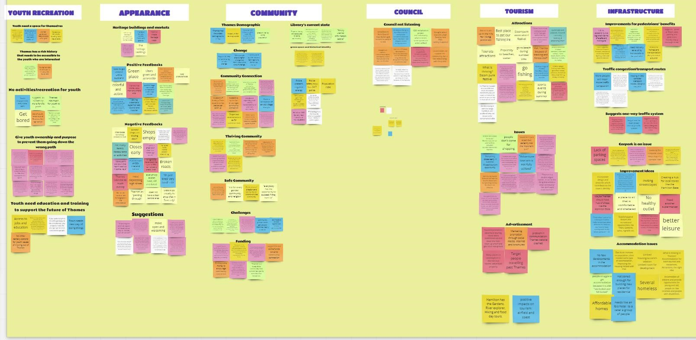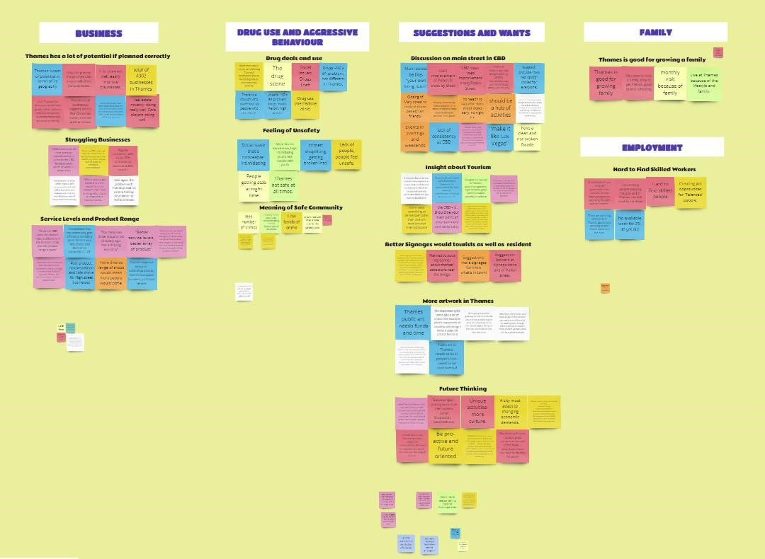

#### IV. All Themes and Insights

1. **TOURISM**

**Theme 1**: Promoting Thames available activities better will get visitors to stop for longer when they are passing through.

**Insights**:

* + Thames is a great place for people who enjoy outdoor activities like fishing, hiking, or beaches
  + Thames is the gateway to Coromandel but tourists or any potential visitor typically pass through for a quick stop.
  + Promotion through the internet (website and social media) and brochures will increase tourism.
  + Thames CBD is composed of many small businesses with cafes being a popular destination. The community itself are very friendly.

**Theme 2**: The community does not want mass tourism and feel that Thames does not cater for tourists

**Insights**:

* + Thames community does not want mass tourism because they are worried tourism will ruin their small community as they feel like Thames is a place for locals
  + Thames does not cater for tourists because there is no available infrastructure at hand.

1. **APPEARANCE**

**Theme**: By improving the Thames CBD with aesthetically pleasing features, the area will feel more welcoming.

**Insights**:

* + Thames has a lot of heritage buildings around the CBD. If the area was improved then everything would look sharper.
  + If Thames were to improve the entrance in some way, then potential customers will want to stop and have a look.
  + Thames is a green place with colonial architecture and easy to get around in the CBD
  + The current appearance of Thames is 'empty' and 'outdated'. Is not much of an inviting environment.

##### C. SUGGESTIONS AND WANTS

**Theme 1**: The community wants better way of representing what’s in the town and affordable and more accommodation for tourists and locals

**Insights**:

* Better signage for the town, the attractions and to represent what is in town would be beneficial for the locals, visitors, and tourists
* Thames locals feel that accommodation for both residents and tourists are limited and there is a need for more accommodation and affordable and accessible housing for all citizens

**Theme 2**: The community want the CBD to have more open spaces such as -shared environments/public spaces/green areas

**Theme 3**: The community want the CBD to have more artwork and entertainment

**Insights**:

* It is felt that the focus of the CBD needs to be around creating a shared environment, the focus on putting cars through them needs to shift to recreating areas that are only for walkers and cyclists
* Smart streetlights could improve the feeling of safety and improve energy efficiency
* There is a need for Thames CBD to have something that identifies itself as well as a vision for its township
* The CBD should be your main point of entertainment and hospitality and there is a need for more of a variety of businesses
* The CBD needs to be comfortable enough for people to want to stay and walk around
* Thames community feel that there is a massive need for big, bold artwork in the CBD and along pollen street, Thames is the gateway to the Coromandel and there is need for some big art to say welcome
* Thames’ community feel that there is a lack of consistency within the CBD, it should be a hub of activities however shops close early, there is no nightlife and there is a need for events in the evenings and on weekends
* Thames community feel that there is a need for murals, laser cut, panel fencing and overall improvements along pollen street (main street in the CBD)

##### D. COUNCIL

**Theme 2**: The District Council is not listening and communicating well to the community

**Insights**:

* Consultations from Council must be brought out for people
* Council has a bad relationship with the public, Council does not support the community.
* A common theme is that the Council does not seem to listen much anyway. It is more of central and local government working together in this town.

**Theme 2**: The District Plan is a document that defines the purpose of land, whereas the Resource Management Act protects the natural and physical resources within the district.

**Insight**:

* There are a lot of rules and regulations inhibiting the development of Thames.

##### E. COMMUNITY

**Theme 1**: Public space to encourage community connection.

**Insights**:

* The community wants a public space/square which encourages community connection and it is a place where events and activities can be held.
* Thames community feels that they are financially limited however they suggest some funds towards encouraging community connection.
* Thames has an interesting historic identity that could be utilized when creating public areas and green spaces.

**Theme 2**: Thames community wants more communication in the community.

**Insights**:

* There will be groups for and against change so it will be difficult to appease both and tap into the large group who do not care or do not know about the planned changes.
* Thames community groups find it challenging to communicate and work together. Events are organised but the groups feel that the event is not targeted for them.
* Thames locals want a community that interacts with each other and helps each other out. They want to feel safe and support local businesses. They want a community that has shared visions and a clear sense of direction
* The community thought that the Council's plan was not effective considering that no support, consultation, and communication was given. **Theme 3**: Thames has an older population

**Insights**:

* 1/3 of the Thames community are over 65 years old.
* The Thames library is adequate for the community as it is, but it is currently heading towards a community hub meaning the older population might not be catered for.

##### F. INFRASTRUCTURE

**Theme 1**: Create green, and hospitality space, pedestrian connection and an artwork that will recognise the town's identity.

**Insights**:

* Improving the accessibility and connection of pedestrians throughout the CBD will further enhance its vitality.
* Creating a green and hospitality space would further add vibrancy to the CBD. ● Incorporate an artwork that will recognise the town's identity and culture.

**Theme 2**: Making a one-way traffic system will provide open space and connection to the community.

**Insights**:

* Creating a one-way traffic system down the main street may mean better access and could mean the addition of public green areas or art exhibits on either end of the street
* The option of making into a one-way road system will create open space and connection to the community.

**Theme 3**: Revitalisation of CBD means a variety of shops and a hub.

**Insights**:

* Thames does not have much variety of shops to choose from. In Thames there are many $2 shops, bakeries, and cafes
* Thames CBD should be revitalized into a hub including variety of shops and recreational opportunities.

**Theme 4:** Parking and traffic congestion are two major problems at Thames considering it is only a small town.

**Insights**:

* Thames is a small town so traffic congestion could become a Major issue with a higher population.
* Lacking free spaces for vehicle parking is a major problem in Thames in terms of getting people to the CBD.

**Theme 5**: There is an inadequate accommodation and a need for restoration of historical buildings.

**Insights**:

* Restoration of old or historical buildings is required to provide safety.
* There is limited accommodation in Thames because of the limited room available for development.
* Some of Thames' infrastructure is adequate as it is, investing more money may not be the answer.

**Theme 6**: There are no other choices for public transportation within the CBD.

**Insights**:

* Different modes of transportation within NZ will be able to access and get around these places.

**Theme 7**: Infrastructure facilities planning, and development is behind the current requirement.

**Insight**:

* One main problem: 30-50 years behind on district planning.

##### G. BUSINESS

**Theme 1**: Business is an important part of the CBD and community and needs support/competition to enhance product/range/service/customer base.

**Insights**:

* If businesses are lacking in competition, then they may not feel a need to up their service & products quality.
* Business is an important part of any town/city, so when planning it is important to consider them and the potential, they must support the community.
* Stores are either empty or closed from the lack of customers.
* Low or incorrect target customers and shops closing early mean Thames' businesses are struggling with their customer base.

**Theme 2**: Many people are on a benefit and cannot find suitable work, employees are struggling to find skilled workers.

**Insights**:

* Employers are struggling to find skilled workers and people are struggling to find suitable work - many are on a benefit.

##### H. FAMILY

**Theme**: Thames provides the essentials for families to live, but there is little entertainment.

**Insights**:

* Because of the lifestyle and assets Thames has it is good for raising a family.
* There is a lack of family-oriented activities in Thames.

##### I. EMPLOYMENT

**Theme**: It is very hard to find skilled workers at Thames.

**Insights**:

● Employers are struggling to find skilled workers and people are struggling to find suitable work.